Part # 12603 Big-Block Chevy V8 Conversion Front Mount

NOTE: 1. To be used to install Big Block Chevy V8 into 1975-77 Vega, 1975-77 Monza, and 1976-77 Skyhawk, Astre, Starfire.
- To be used with Hooker Headers part No. 2240.
- Use Hooker Transmission Mount (see year and type of transmission).
 | Year/Make | 400 Turbo Hydromatic ONLY | 350 Turbo Hydromatic – All GM Manual Trans. w/ Tail Mount Trans Mount, Aluminum Case Powerglide
 | ’71-74 Vega | Part No. 12625 | Part no. 12627
 | ’75 Vega/Monza | Part No. 12632 | Part No. 12633
 | ’76-77 Vega, Monza, Skyhawk, Astre, Starfire | Part No. 12634 | Part No. 12635
- Installation kit will not work on vehicles equipped with air conditioning, power brakes, or power steering.

Thank you for making Hooker Headers your choice in a high performance engine conversion kit. Hooker Headers had designed the finest conversion kit available for the Chevrolet Vega with a big-block Chevrolet V8 engine.

Before Starting
Your vehicle must be raised a minimum of 36 inches. A floor hoist is ideal. If not hoist is available, we strongly urge the use of axle stands as a safety measure. CAUTION! Your car should not be supported on a bumper jack. A good engine hoist is also necessary to install and position engine for certain parts of this installation.

Installation Procedure – Please Read Carefully
- Disconnect battery. Mark all wires and cables. Remove hood, radiator, engine, transmission engine mounts, frame pad for engine mounts, rear transmission crossmember, heater core housing, heater core, speedometer cable, steering column, all wires, cables, and brake lines that are attached to the lower part of firewall and front section of drive tunnel.
- Using a large hammer (6-8 pounds) or an air hammer, reshape the firewall and drive tunnel approximately 2” up at center, 1” on the sides, tapering back about 10” from the firewall. Additional reshaping if aftermarket scatter-shield is used. Reshaping also necessary for clearance for distributor and left valve cover to clear firewall. See illustration “A”. Reshape an area on the right side between the lower A-arm attaching point approximately ½” to provide clearance for starter. See illustration “B”. Removal of section of lip shown in illustration “A” is optional for removal of distributor once engine is installed in vehicle.
- Using instruction sheet install rear crossmember and transmission mount. A trial fit of he bellhousing and/or transmission is suggested to see that there is a minimum of ½” clearance between transmission on transmission mount. Use a hydraulic jack to hold the front of transmission sight down the input shaft of transmission mount on an imaginary straight line to the pinion flange. This method will determine the approximate location of transmission and clearance available.
- An oil pan from a 1969 big-block Camaro must be used to clear crossmember. Also, if a manual transmission is to be installed, a bellhousing and throw-out bearing arm from a 1975-79 V8 Monza is highly suggested. If a stock bellhousing is installed, use Hooker clutch bracket, Part No. 10941.
- Before installing heater the heater core must be turned around so that the hoses will attach to the outside. New holes will need to be drilled in heater core housing for hose connection. Also, housing will need to be reshaped to clear right head and valve cover of engine.
- Using an engine hoist, lower engine transmission package down into chassis. Position transmission on crossmember. Center it front to rear in slots on transmission mount. Tighten all bolts securely.
- Attach front engine loop to engine using supplied spacers, bolts, and lock washer. See illustration “C”. Bolt frame pads to front loop placing rubber mounts between frame pad and engine loop. Tighten (3) bolts until rubber is compressed 1/16”-1/8”. Position engine in chassis and weld frame pads to frame.
NOTE: If vehicle needs to be moved to be welded, drill ¼” holes in frame using holes in frame pads as templates. Install 3/8” self-taping bolts and tighten. This is only temporary. Vehicles should not be moved under own power until frame pads are securely welded.
 | 12603
 | 12603 |   Super Competition
Part # 12603
PAGE 2
- A new steering column must be fabricated. See illustration “D” for a suggested example. All universal mounting hardware and welding should be aircraft quality. Once new column is installed check to see that no binding exists. Tighten all bolts securely.
NOTE: Universal joints of the type and quality necessary may be purchased from Harwood Inc., SRD Race Cars, Russel Performance Products Inc.., the better equipped speeds shops and some government surplus stores.
- A 1964-67 Corvette radiator is suggested to provide adequate cooling. The stock radiator core supports must be cut and the grille, splash panel must be altered. See illustrations “E” and “F”.
NOTE: An early model water pump (short shaft) and single groove pulley must be used on harmonic balancer to provide adequate fan clearance. Radiator must be mounted in rubber ahead of stock radiator position. A Hooker Vega front spoiler is suggested to cover and protect bottom of radiator. A fabricated fan shroud is also advisable.
- A stock throttle cable will work with minor modifications. A late model air filter for a Corvette or equivalent is necessary for hood clearance.
- On vehicles equipped with manual transmission the stock Vega clutch cable will work with either the Monza bellhousing or with Hooker clutch bracket, Part No. 10941. The clutch cable from 1975-77 Monza V8 is recommended for heavy duty application.
- Install some type of remote oil filter system.
- Install Hooker Headers Part No. 2240 as per instructions.
- An early type alternator bracket is necessary so that fan belt will line up with other pulleys. Bracket should be modified as shown in illustration “G” to clear front engine loop.
- Tighten all nuts securely. Attach wires and hoses. A modified drive shaft must be fabricated.
- A narrowed 10 or 12 Bolt Chevy is suggested. A modified drive shaft must be fabricated.
- Heavy duty front springs are suggested to compensate for additional weight of new engine.
Any questions? Please contact the Customer Service Department at: Hooker Headers, 1024 West Brooks Street, Ontario, California 91762, or phone (909) 983-5871. Thank you.
Did you know there is more to hooker than just headers? Of course, we love our Hooker headers, but Hooker builds more than the ultimate in high performance exhaust systems. Ask your dealer or send us $4.00 and we’ll send you complete information plus Hooker decals.
Limitation of Liability – Disclaimer: The regulation of emissions production, noise levels and safety standards is undertaken by the federal government, each of the fifty state legislatures and by many local municipalities, towns and countries.
Hooker Industries makes no warranties of merchantability, of fitness for particular purpose, or that its products are approved. For general use, or that its products comply with laws, regulations or other ordinances in the states where they may be sold to the ultimate purchaser, the consumer.
Unless expressly stated to the contrary in the accompanying catalog, instruction sheet or price list, the entire risk as to the conformity of any company product in any such state and as to repair should the product prove to be defective or nonconforming, is on the retail purchaser, the buyer, the ultimate consumer, of such product and it is not upon the seller, distributor or manufacturer.
In the connection, retail purchaser, the buyer, the ultimate consumer assumes the burden of the entire cost of any and all necessary service, alterations or repair.
The forgoing statement limits the liability of the manufacturer.
California vehicle code sections 27156 and 38391 prohibit the advertising, offering for sale, or installation of any device which modifies a vehicles emission control system unless exempted. Unless otherwise noted, Hooker headers have not received an exemption from these code sections and are not legal for sale or use in California on vehicles originally equipped with catalytic converters. It is illegal, except for racing vehicles which may never be driven upon a highway, to remove or otherwise render inoperative any emission control device on regulated motor vehicles-check catalog listings to insure proper application. In the other 49 states, unless otherwise noted, Hooker headers are not legal for pollution controlled motor vehicles, except for racing vehicles which may never be used upon a highway and are not intended or applicable for highway use.
Part # 12603
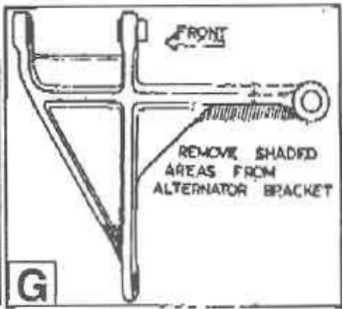
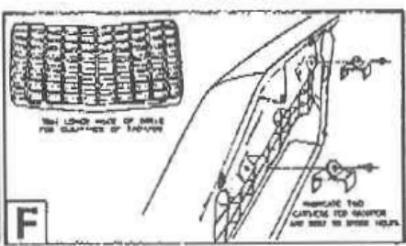
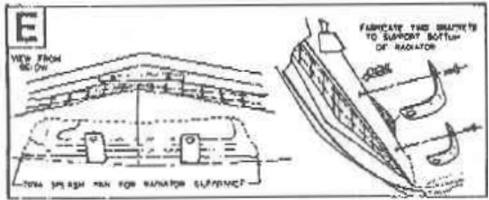
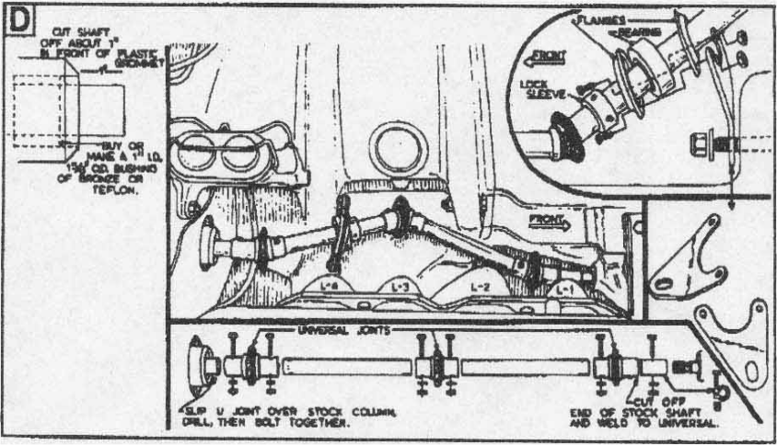
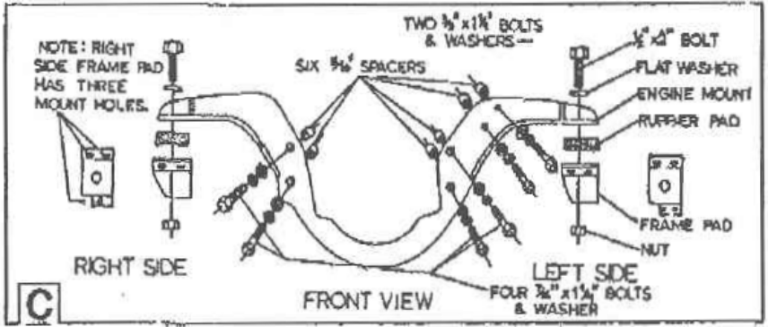
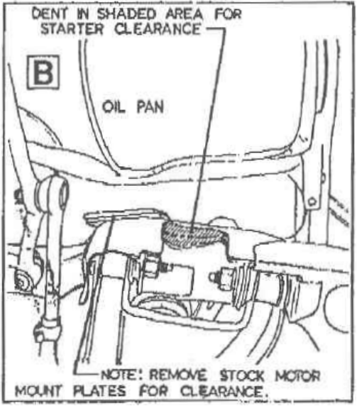
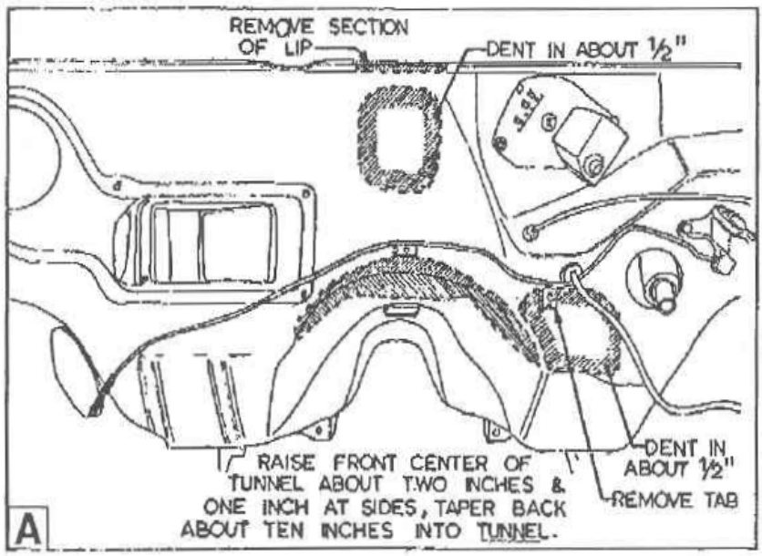
PAGE 3

